5E Lesson 1: Discovery Tube- Science
Name: Jeanette Fehr |  | Date: July 12, 2011
Content Area: Earth Sci. | Grade Level(s): 9+ | Topic(s): Nature of Science

Standards (SOL)
Earth Science SOL Standard
ES.1c,e
ES.2a,b,c,d

Objectives (UKD’s)
Students should be able to:
1. Differentiate between terms ‘fact’ and ‘inference’
2. Using observations, list facts about the object
3. Using observations, list inferences about the object
4. Based on facts and inferences, predict a design and construct a model
that replicates the actions and reactions of the demonstration object

Materials & Resources

Demo-object for front of room (Discovery Tube):
(see diagram 1—but do not share with students)
- 1 large cardboard mailing tube (poster-size); drill or poke a hole through one side of the tube one side & out the other toward the top of the tube. Drill or poke a hole through one side of the tube one side & out the other toward the bottom of the tube.
- 2 pieces of rope; each should be long enough to floss through the holes from side-to-side, but either cross the ropes, floss them through a key ring, or small tube
- Key ring or small tube (optional)
- Painting supplies or stickers to decorate large tube (optional)
- Knot all four ends of rope and secure end caps with tape or duct tape

Class-size demo object(s) (Discovery Tubes): *The more tubes available, the more actively involved the kids become simultaneously, & it saves time.
(See diagram 1—but do not share with students)
6. For Each Student: Copy of Word document Discovery Tube Directions in
landscape format—front & back

7. Sturdy cardboard tubes (empty saran wrap tube); drill or poke a hole
through one side of the tube one side & out the other toward the top of
the tube. Drill or poke a hole through one side of the tube one side & out
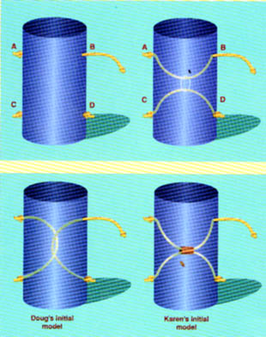
the other toward the bottom of the tube.
- 2 pieces of rope per tube; each should be long enough to floss through the holes from side-to-side, but either cross the ropes, floss them through a key ring, or small tube
- Key ring or small tube (optional)
- Knot all four ends of rope and secure end caps

Supplies for kids
- Empty paper towel and toilet rolls
- Scissors
Diagram 1
- String, yarn, twine, or thin rope
- Key rings or small cylinders
(add a variety of supplies for kids to increase level of creativity)

Teaching About Evolution and the Nature of Science. (1998). Washington, DC:
National Academy Press. 23-25

Safety Considerations

Extra care should be taken if students work with scissors and poke holes through their cylindrical objects.

Engage – Time Estimate 10 minutes

- Post objectives on the board prior to student entry
- Think-Pair-Share w/ seat Partner (Shoulder Buddy—Dan Mulligan) about the concepts/ differences of Facts and Inferences
- Use the large (Discovery Tube) object to stimulate interests—hold it vertically
- *Engage a class discussion listing only facts about the object
- Engage a class discussion listing only inferences about the object
- Use the Discovery Tube PowerPoint page 3 to show interactive discussion. If inquiries are made about pulling the rope, invite student to the front to lead the investigation… pull a top rope-end—pull the other side on top. Repeat. Have student pull a bottom rope-end…then whatever rope-end he/she wants to pull.

*Within the Resource, a script (Dialogue) between two people is provided:
In the following vignette, Barbara, Doug, and Karen use a model to continue their discussion of the nature of science and its implications for the teaching of evolution.
********
"Thanks for meeting with me this afternoon," Barbara says. "To begin this demonstration I first need to ask you what you think science is."
"Oh, I had that in college," says Karen. "The scientific method is to identify a question, gather information about it, develop a hypothesis that answers the question, and then do an experiment that either proves or disproves the hypothesis."
"But that was one of my points about evolution," Doug says. "No one was there when evolution happened and we can't do any experiments about what happened in the past. So by your definition, Karen, evolution isn't science."
"Science is a lot more than just supporting or rejecting hypotheses," Barbara replies. "It also involves observation, creativity, and judgment. Here's an activity I use to teach the nature of science."
Barbara takes a cardboard mailing tube about one foot long that has the ends of four ropes extending from it.
As Barbara tugs on the various ropes one at a time, she has Doug and Karen make observations of what happens. After three or four pulls, she asks Karen and Doug to predict what will happen when she pulls on one of the ropes. Both are able to predict that if Barbara pulls rope A, rope B will move. Barbara then asks if there are additional manipulations they would like to see, and she follows their requests.
Barbara then asks Doug and Karen to sketch a model of what is inside the tube that could explain their observations.
When Karen and Doug show their sketches to each other, they realize that they have come up with different models. Barbara asks them if they want to make any changes to their sketches based on the comparison, and both of them make modifications, although their final models are still different.
Barbara then gives them their own cardboard tubes and some string and asks them to build the model they proposed. When their models are built, Barbara holds up her tube and asks Doug and Karen to follow her actions with their own models, to see if the two models behave in the same way as Barbara's tube. But when Barbara pulls string A in her tube, Karen's model does not work the same way. Karen asks if she can make some changes in her model, and once she does her new model seems to work the same way as Barbara's. Doug's model consistently behaves the same way as Barbara's tube.
"Now wait a minute," Karen says. "What do ropes and tubes have to do with science and evolution?"
"You might not know it, but what we just did is much of what science is about. You observed what happened when
I pulled these ropes. Then, based on your initial observations, you made a prediction about what would happen if we manipulated the system in a specific way. How accurate was your prediction?"
"We were right," Doug responds.
"And why were you able to predict what would happen before I pulled the rope?"
"I used what I observed in the first few pulls to help me predict what would happen later."
"Basically what each of you did was to speculate about how my tube was working on the basis of some limited observations. Scientists do that type of thing all the time. They make observations and try to explain what's going on, or sometimes they recognize that more than one explanation fits their data. Then they try out their proposed explanations by making predictions that they test. At first I had you draw a picture of how you thought my tube worked and had you each explain your picture. You got to hear each other's view on how the system worked. Doug, did you change your ideas at all based on what you heard from Karen?"
"Well, yes. I first thought that ropes A and C were the two ends of the same rope and B and D were two ends of another rope. Karen had A and B as ends of the same rope and C and D as ends of another rope, and her explanation seemed to fit better than mine."
"Right. Communication about observations and interpretations is very important among scientists because different scientists may interpret data in different ways. Hearing someone else's views can help a scientist revise his or her interpretation. In essence that was what you were doing when you shared your diagrams. Karen, when your model didn't work, what did you do?"
"All I did was adjust the length of one rope, and then it worked fine."

"So as a result of your formal testing of the predictions from your model, you revised your explanation of the system. Your understanding improved. In scientific terms, you revised your model to make it more consistent with your further observations. In science, the validity of any explanation is determined by its coherence with observations in the natural world and by its ability to predict further observations."
"But we still have different models," Karen observes. "How do we know which one is right?"
Doug says: "You told us that, didn't you, Barbara. There can be two possible explanations for the same observation."
"So it's possible for scientists to disagree sometimes," says Karen. "But does that mean that we don't understand evolution because scientists disagree about how evolution takes place?"
"Not at all," Barbara answers, "you both created different models of my tube, but both of your models are fairly accurate. And don't forget there were constraints on
the possible models you could create that would be consistent with the data. Just any explanation would not be acceptable. In evolution, there are some things we know could not have happened, just as we are confident that some things have happened."
"And if different scientists can have different explanations, like Karen and I did, then I guess science also has to involve judgment to some extent," Doug says.
"But I thought scientists were supposed to be totally objective," says Karen.
"Good science always attempts to be objective, but it also relies on the individual insights of scientists. And the questions they choose to ask as well as the methods they choose to use, not to mention the interpretations they may have, can be colored by their individual interests and backgrounds. But scientific explanations are reviewed by other scientists and must be consistent with the natural world and future experiments, so there are checks on subjectivity. What we read in science books is a combination of observations and inferred explanations of those observations that can change with new research."
"Still, I'm wondering," says Karen, "how can we find out which model is right?"
"Let's just open up Barbara's tube," says Doug.
"We could do that," Barbara says. "But let's assume in this analogy that opening the tube is not possible. Sometimes scientists figure out how to open up the natural world and look inside, but sometimes they can't. And not opening up the tube is a good metaphor for how science often works. Science involves coming up with explanations that are based on evidence. With time, additional evidence might require changing the explanations, so that at any time what we have is the best explanation possible for how things work. In the future, with additional data, we may change our original explanation—just like you did, Karen.
"Remember when we were talking this morning about evolution being fact or theory? That conversation is very relevant to what we have been doing with the tubes. As scientists started to notice patterns in nature, they began to speculate about some explanations for these patterns. These explanations are analogous to your initial ideas about how my tube worked. In the terms of science, these initial ideas are called hypotheses. You noticed some patterns in how the ropes were related to each other, and you used these patterns to develop a model to explain the patterns. The model you created is analogous to the beginning of a scientific theory. Except in science, theories are only formalized after many years of testing the predictions that come from the model.
"Because of our human limitations in collecting complete data, theories necessarily contain some judgments about what is important. Judgments aren't a weakness of scientific theory. They are a basic part of how science works."
"I always thought of science as a bunch of absolute facts," says Doug. "I never thought about how knowledge is developed by scientists."
"Creativity and insight are what help make science such a powerful way of understanding the natural world.
"There's another important thing that I try to teach my students with this activity," Barbara continues. "It's important for them to be able to distinguish questions that can be answered by science from those that cannot be answered by science. Here's a list of questions that I use to get them talking. I ask them if a question can be answered by science, cannot be answered by science, or has some parts that belong to science and others that do not. Then I ask the group to select a couple of questions and discuss how they would go about answering them."
********

Explore – Time Estimate 10-15 minutes

- Set-a-timer for 10 minutes: Time can be added
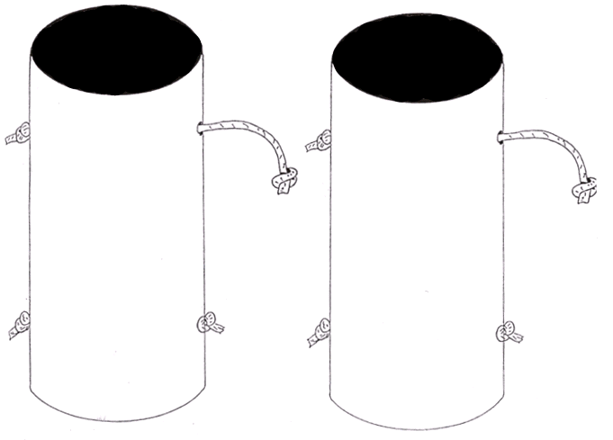
- If class-size demo object(s) (Discovery Tubes) were constructed, have the class pass around the objects for individual opportunities observations. The large Discovery Tube can be used also. (They usually all want to try it; passing one back through each set of rows may be helpful). No tampering permitted.

- Supply students with an opportunity to predict the internal design of the tube from page 4 of the Discovery Tube PowerPoint or from the Word Document Discovery Tube Student

Explain -- Time Estimate 5 minutes
- Set-a-timer for 5 minutes: Pair-Share w/ seat Partner (Shoulder Buddy) the design. What design(s) did you choose and why?
- Students may share designs with the class using the front board or from pg 4+ of the Discovery Tube PowerPoint.

Teachers should circulate: students sketches or designs are NOT wrong. The designs may not look like yours (the teacher’s). Ask the student to explain his/her design to you.

Extend -- Time Estimate 15-20 minutes
- Teachers should compliment all students on their hard work and creativity.
- In order to determine whether or not student designs supports the teacher’s discovery tube by replicating the actions/reactions, students are challenged is to construct a model of their own.
- Set-a-timer for 15-20 minutes: Time can be added
- Provide a variety of supplies for students to use; let them gather supplies and be creative

Evaluate -- Time Estimate 10-15 minutes

- Teacher observes students summarizing & assessing their own work & listen to the Pair-Share w/ seat Partner (Shoulder Buddy) discussions between the kids

- The Discovery Tube PowerPoint page 7 and page 2 of the Word document Discovery Tube Student have summery/assessment questions. It is not necessary that each student-designed tube works exactly as the teacher’s demonstration tube.

- Students think and finish the summary questions on their own then Pair-Share w/ seat Partner (Shoulder Buddy)

Plans for Diversity
Student(s): Category/Characteristics: Accommodations:

- special needs students, ELL’s: may need clarification: Try to make/build a tub model like the teacher’s tube. Accommodations: stronger/faster student can be paired;
- special needs students, Accommodations: copy of teacher notes about observational facts and inferences
- Students w/limited motor skills in hands; Accommodations: pair another student with motor skills and compassion

Connections

--A great activity to ‘begin teaching science’ the first day of school. It ties VA SOLs with scientific investigation and is generally found early in the scope and sequence of the course. It also uses the higher-level thinking strategies of the new Blooms Taxonomy.

If the teacher supports the notion of not disclosing the tube’s actual design to the students, then the aspect that ‘science does not always find answers’ yet people long for explanations derived from observations. The Nature of Science can be interwoven through many concepts of Earth Science when observations are used to gather facts, and inferences are made to make predictions about the world around us. For instance, the ‘Big Bang’ & ‘Dinosaur Extinction’—we acquire evidence to support, but not prove those theories—unless we (humans) witnessed a particular event. Whenever students inquiry during the year, “How do scientists know… for sure?” The students can reflect back to their own design of the discovery tube experiment—did they replicate the actions & reactions of the ‘teacher’s discovery tube? Did it work? How do they know for sure?

The activity can also be used to show general scientific method steps or the experimental design process. The different types of designs can be tallied and graphed.

Discovery Tube Activity
Objectives:

- Think-Pair-Share with seat/shoulder partner: Describe the differences between ‘facts’ and ‘inferences’
- Using observations, list facts about the object
- Using observations, list inferences about the object
- Based on the facts and inferences, predict a design and construct a model that would replicate to actions and reactions or the demonstration model. (supplies provided)
We made observations then inferences based on what you saw happen to the rope when the ends were pulled. On the front of this paper, you and your partner are to reconstruct the inside of the tube based on observations during class.
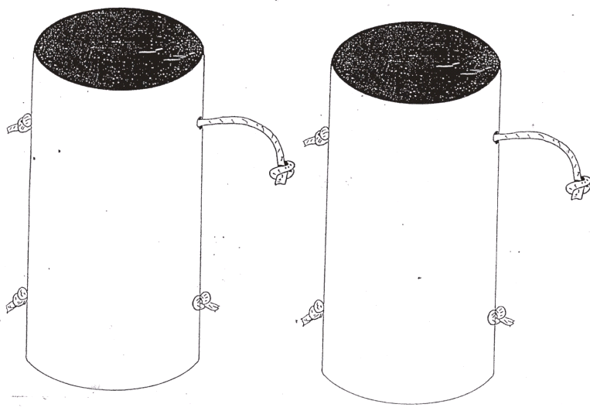

* Tampering with the tube (caps, enlarging rope holes, breaking the tube, etc.) is prohibited
Summarize on your own first: (In a complete sentences), then we’ll share…

- Explain the difference between a ‘fact’ and ‘inference’

______________________________________________________________________________

______________________________________________________________________________

- How can a prediction be supported through the scientific observations.

______________________________________________________________________________

______________________________________________________________________________

- What could you do if you were asked to support your prediction about the tube design?

______________________________________________________________________________

______________________________________________________________________________

- Did the tube design you chose to design and create support your prediction about the activity?
Why or why not?
______________________________________________________________________________

______________________________________________________________________________

